Data Structures

And

Algorithms

Assignment 1

Name: Madhav K Mohan

AIML B

RA2311026050003

1. **Implementation of Structures (Define a structure named Friends with members: name, pet name, phone number, and a nested structure named Type with members: Type of friend (School, College or Area friend), name of common friends and places visited together. Write a C program to input atleast 3 friends data and display the details in proper time format.)**

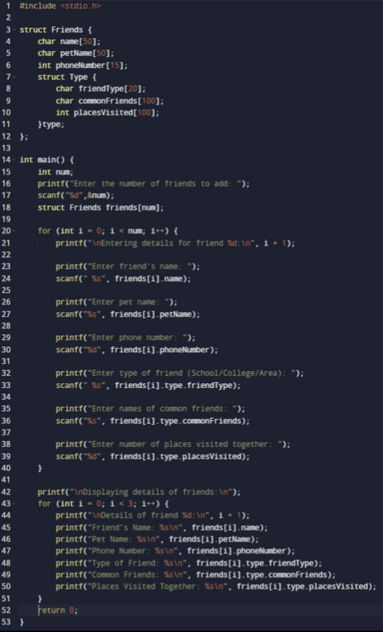**Input:**

**Output:**  
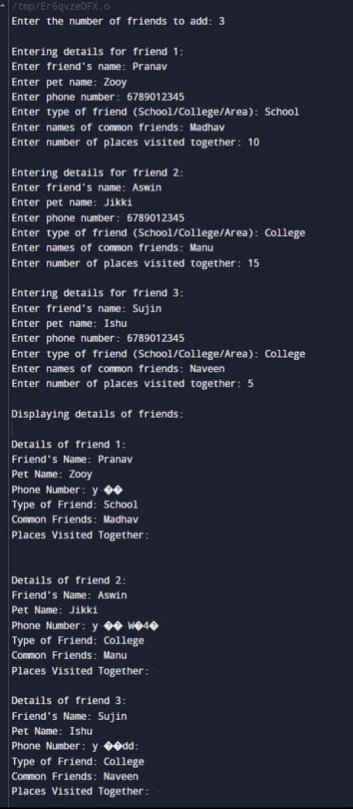

**2. Implementation of Structures using Pointers (Create a structure named Product to store details of the product like name, ID and price. Write a C program to input details for at least 5 products, find the Total cost of all products, the most expensive and the lowest priced product, and display their information.)**

**Input:**



**Output:**